NUTRITION WEBQUEST

This WebQuest will give you the information you need to make good decisions about your overall wellness. The goal of this activity is for you gain insight on the essential nutrients, analyze food labels, explore nutritional guidelines and incorporate healthy eating decisions into your daily life.

TASK #1: Essential Nutrients
TASK #2: Nutrients Video
TASK #3: Food Labels
TASK #4: Calories
TASK #5: Fast Food Nation

ESSENTIAL NUTRIENTS
http://healthyeating.sfgate.com/6-essential-nutrients-functions-4877.html
Define Nutrient:
There are 6 nutrients: use the link above to complete the chart.

NUTRIENTS VIDEO
YOUTUBE CLIP: Essential Nutrients
What is the major source of energy for the body?
What are the two types of Carbohydrates?

Name a “healthy” simple sugar
Name a “non-healthy” simple sugar
Another name for a complex carbohydrate is
What is HDL? https://www.cdc.gov/cholesterol/ldl_hdl.htm

What is LDL?
Use above link

 | What does the below do for your body? | Where is it found? Examples?
Proteins
Vitamin A
Vitamin C
Calcium
Iron
Fats
3 types

How much of your body is made up of water?
Where do you get the majority of the water that you intake daily

FOOD LABELS
How to read a Nutrition Facts label? Click on the link below and answer the following:
https://choosemyplate-prod.azureedge.net/sites/default/files/sites/default/files/images/NutritionFactsLabel.pdf
What does a food label make easy?
What should you strive for each day?
Always include!
Choose foods low in the following:
Regular physical activity is important for
Using both the link above and the one below this line, answer the following questions on food labels
https://www.move.va.gov/docs/NewHandouts/Nutrition/N10_HowToReadAFoodNutritionLabel.pdf
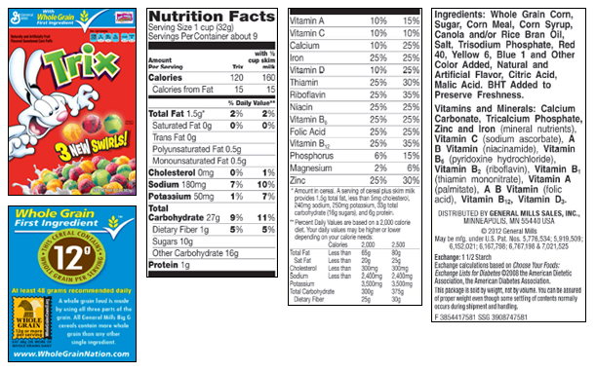
How many calories are in a serving without milk?
How many carbohydrates are you eating?
What is the serving size?
How many calories from protein?
What is the main ingredient/where found?

CALORIES
https://www.youtube.com/watch?v=U4W78cnN0OU
What is a calorie
How is it described

- How many calories are in one gallon of car fuel?

- How many miles would you go on one calorie?

- How many calories do the following contain and converting grams to calories?
http://healthyeating.sfgate.com/convert-fat-grams-calories-5127.html
Calories per gram
Proteins
Carbohydrates
Fat
Example or fat | Cal/gram | Total Cal
12 grams X |  | =
7 grams X |  | =
3 grams X |  | =

- How do we use our calories?

- Where do un-used calories go?

- What happens when fat cells grow?

- For every gram of fat, there are how many calories

FAST FOOD NATION

Americans spend billions of dollars at restaurants and fast food establishments a day. Do you know what you are eating? Your task: Research 2 restaurants: Sit-down (Red Robin, Texas Road House, Applebee’s) and a typical fast food (BK, McDonalds, Wendy’s, Chipotle, Chick-fil a). Pick your typical meal from the chosen establishment and find the caloric value of this meal. Use: http://www.myfitnesspal.com/food/search
RESTAURANT #1: Sit-Down Meal:
LIST CHOICE | Total  FATS | Total  Protein | Total  Carbs | Total  CALORIES
MAIN COURSE:
SIDE ITEM:
BEVERAGE:
DESSERT

RESTAURANT #2: Typical Fast Food Meal:
LIST CHOICE | Total  FATS | Total  Protein | Total  Carbs | Total  CALORIES
MAIN COURSE:
SIDE ITEM:
BEVERAGE:
DESSERT
Your reaction to these meals: Is this a healthy meal option? How do you make these healthier?

