Name: _____________ Bell: ____
Hungry Planet: What the World Eats
Using the photos and information provided, answer the questions below.
- Which family (give the country name) spends the most on food for a week?
How much do they spend (in dollars) for each member of the family?

- Which family spends the least on food for a week? How much do they spend (in dollars) for each member of the family?

- What could this reveal about the family’s (from #2) standard of living and the circumstances of the family members’ lives?

- Which family eats the largest variety of different foods? Why?

- Which family do you think eats the freshest, highest quality food? Why?

- Which family do you think has a diet that most closely resembles your own? What are the similarities?

- Imagine that you are looking for a unique and educational dining experience in another family’s home. Which family do you think could best provide you with this
experience? Why?

- Imagine also that this same family joins you and your family for a typical dinner at your home. What do you think the members of that family would say to each other about this meal when they returned home?

- What brands did you recognize? How did you know the brand?

What the World Eats
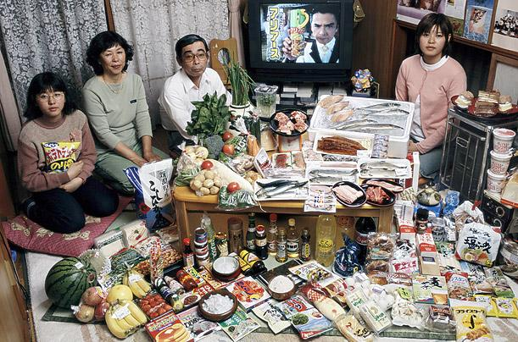
Japan: The Ukita family of Kodaira City
Food expenditure for one week: 37,699 Yen or $317.25
Favorite foods: sashimi, fruit, cake, potato chips

What the World Eats
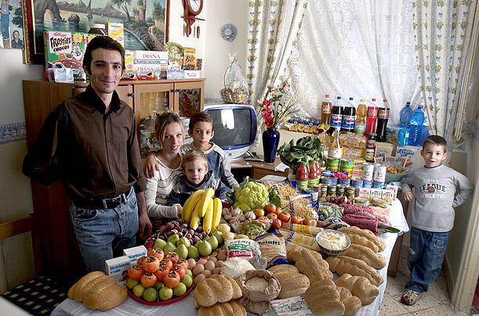
Italy: The Manzo family of Sicily
Food expenditure for one week: 214.36 Euros or $260.11
Favorite foods: fish, pasta with ragu, hot dogs, frozen fish sticks
What the World Eats
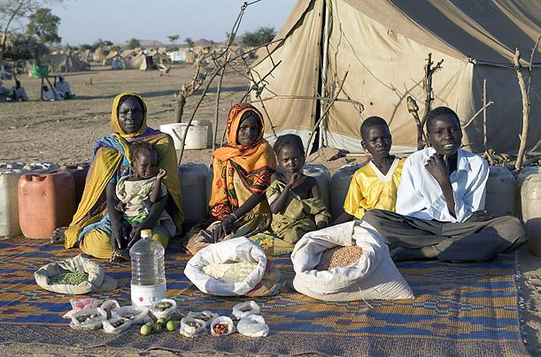
Chad: The Aboubakar family of Breidjing Camp
Food expenditure for one week: 685 CFA Francs or $1.23
Favorite foods: soup with fresh sheep meat
What the World Eats
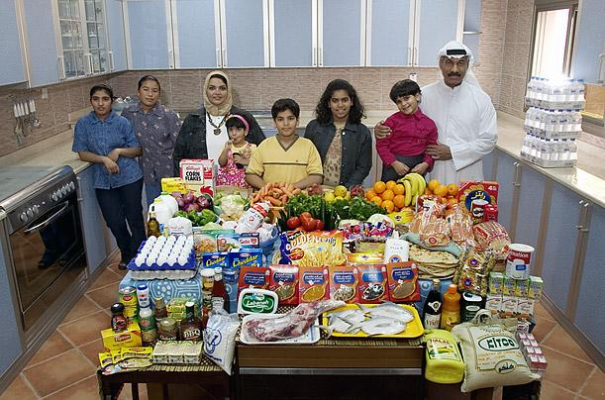
Kuwait: The Al Haggan family of Kuwait City
Food expenditure for one week: 63.63 dinar or $221.45
Favorite Family recipe: Chicken biryani with basmati rice
What the World Eats
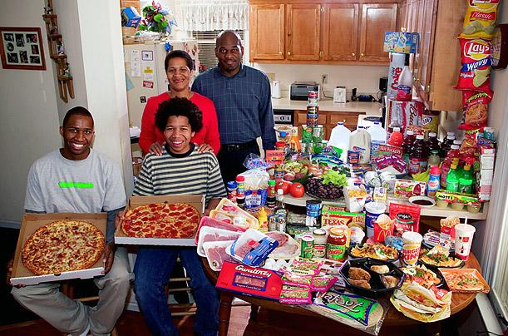
United States: The Revis family of North Carolina
Food expenditure for one week: $341.98
Favorite foods: spaghetti, potatoes, sesame chicken
What the World Eats
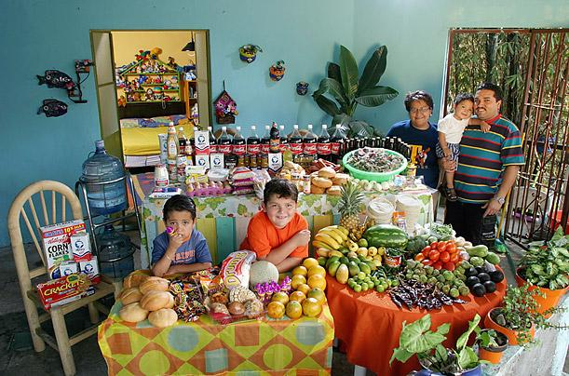
Mexico: The Casales family of Cuernavaca
Food expenditure for one week: 1,862.78 Mexican Pesos or $189.09
Favorite foods: pizza, crab, pasta, chicken
What the World Eats
China: The Dong family of Beijing
Food expenditure for one week: 1,233.76 Yuan or $155.06
Favorite foods: fried shredded pork with sweet and sour sauce
What the World Eats
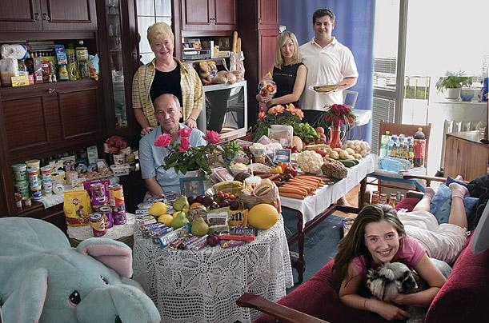
Poland: The Sobczynscy family of Konstancin-Jeziorna
Food expenditure for one week: 582.48 Zlotys or $151.27
Family recipe: Pig's knuckles with carrots, celery and parsnips
What the World Eats
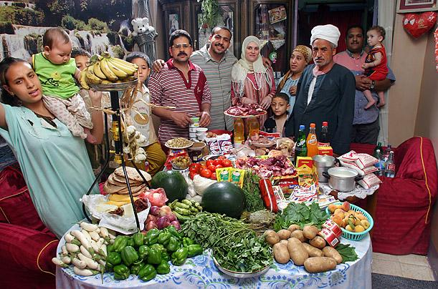
Egypt: The Ahmed family of Cairo
Food expenditure for one week: 387.85 Egyptian Pounds or $68.53
Family recipe: Okra and mutton
What the World Eats
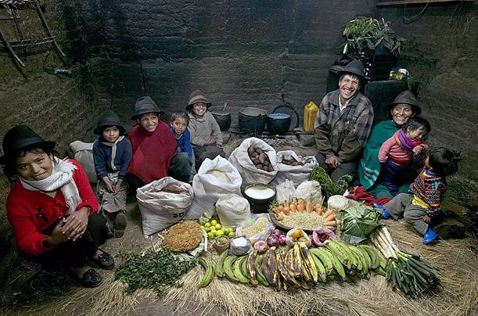
Ecuador: The Ayme family of Tingo
Food expenditure for one week: $31.55
Family recipe: Potato soup with cabbage
What the World Eats
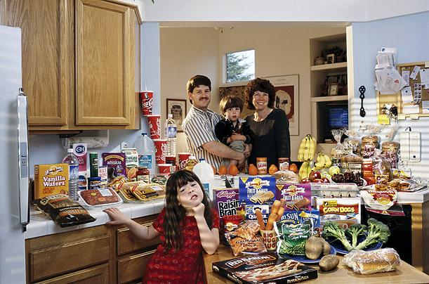
United States: The Caven family of California
Food expenditure for one week: $159.18
Favorite foods: beef stew, berry yogurt sundae, clam chowder, ice cream
What the World Eats
Mongolia: The Batsuuri family of Ulaanbaatar
Food expenditure for one week: 41,985.85 togrogs or $40.02
Family recipe: Mutton dumplings
What the World Eats
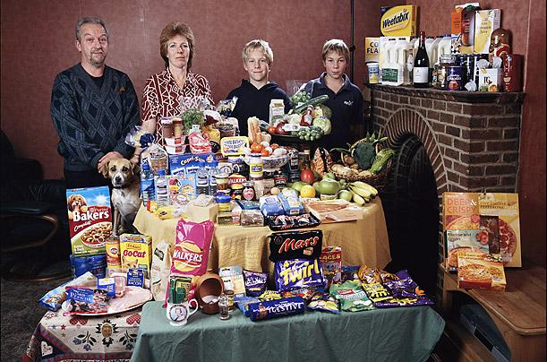
Great Britain: The Bainton family of Cllingbourne Ducis
Food expenditure for one week: 155.54 British Pounds or $253.15
Favorite foods: avocado, mayonnaise sandwich, prawn cocktail, chocolate fudge cake with cream
What the World Eats
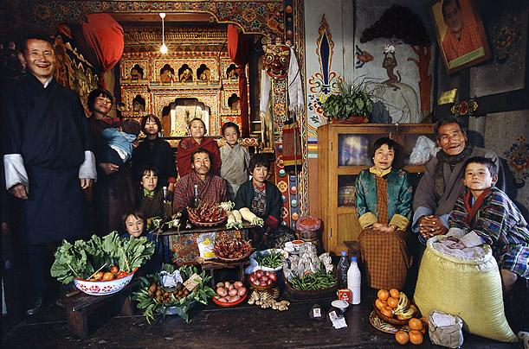
Bhutan: The Namgay family of Shingkhey Village
Food expenditure for one week: 224.93 ngultrum or $5.03
Family recipe: Mushroom, cheese and pork
What the World Eats
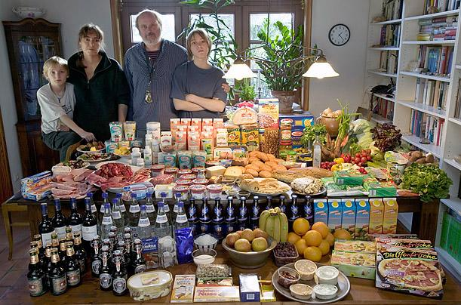
Germany: The Melander family of Bargteheide
Food expenditure for one week: 375.39 Euros or $500.07
Favorite foods: fried potatoes with onions, bacon and herring, fried noodles with eggs and cheese, pizza, vanilla pudding
Hungry Planet: What the World Eats
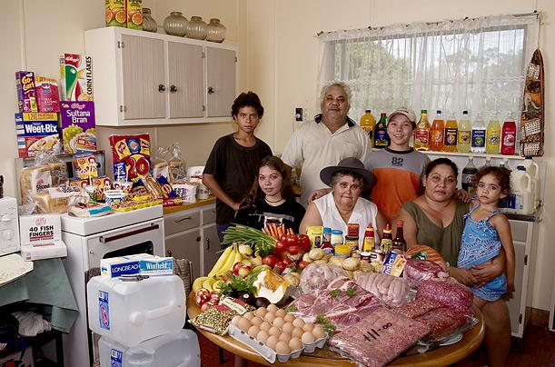
Australia: The Browns of River View
Food expenditure for one week: 481.14 Australian dollars or US$376.45
Family Recipe: Marge Brown's Quandong (an Australian peach) Pie, Yogurt
Hungry Planet: What the World Eats
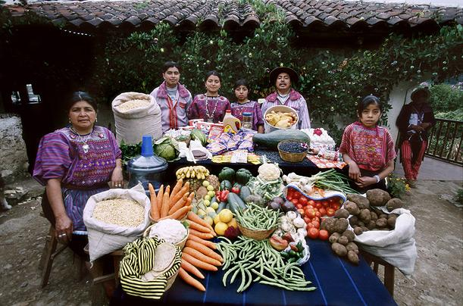
Guatemala: The Mendozas of Todos Santos
Food expenditure for one week: 573 Quetzales or $75.70
Family Recipe: Turkey Stew and Susana Perez Matias's Sheep Soup
Hungry Planet: What the World Eats
Luxembourg: The Kuttan-Kasses of Erpeldange
Food expenditure for one week: 347.64 Euros or $465.84
Favorite Foods: Shrimp pizza, Chicken in wine sauce, Turkish kebabs
Hungry Planet: What the World Eats
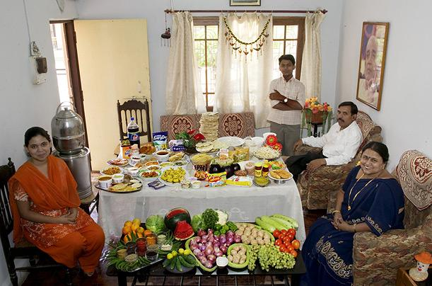
India: The Patkars of Ujjain
Food expenditure for one week: 1,636.25 rupees or $39.27
Family Recipe: Sangeeta Patkar's Poha (Rice Flakes)
Hungry Planet: What the World Eats
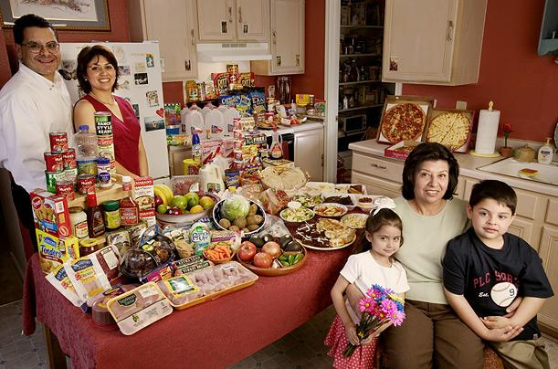
United States: The Fernandezes of Texas
Food expenditure for one week: $242.48
Favorite Foods: Shrimp with Alfredo sauce, chicken mole, barbecue ribs, pizza
Hungry Planet: What the World Eats
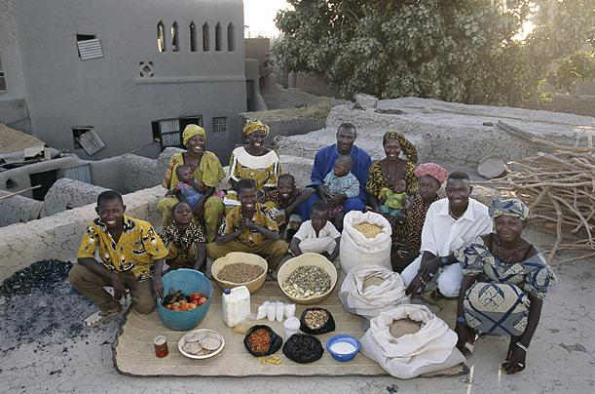
Mali: The Natomos of Kouakourou
Food expenditure for one week: 17,670 francs or $26.39
Family Recipe: Natomo Family Rice Dish
Hungry Planet: What the World Eats
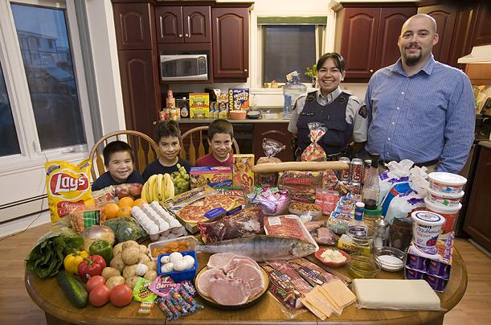
Canada: The Melansons of Iqaluit, Nunavut Territory
Food expenditure for one week: US$345
Favorite Foods: narwhal, polar bear, extra cheese stuffed crust pizza, watermelon
Hungry Planet: What the World Eats
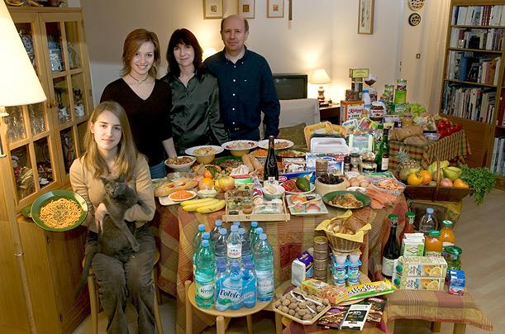
France: The Le Moines of Montreuil
Food expenditure for one week: 315.17 euros or $419.95
Favorite Foods: Delphine Le Moine's Apricot Tarts, pasta carbonara, Thai food
Hungry Planet: What the World Eats
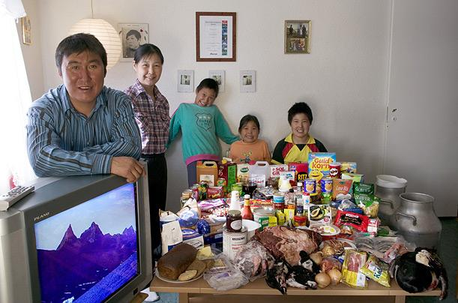
Greenland: The Madsens of Cap Hope
Food expenditure for one week: 1,928.80 Danish krone or $277.12
Favorite Foods: polar bear, narwhal skin, seal stew
Hungry Planet: What the World Eats
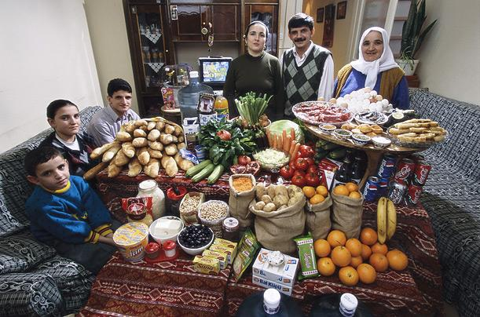
Turkey: The Celiks of Istanbul
Food expenditure for one week: 198.48 New Turkish liras or $145.88
Favorite Foods: Melahat's Puffed Pastries

